Regency Trailers

Unit 2, 16 Rob Place, Vineyard NSW 2765, 02 45779727

**QUOTE**

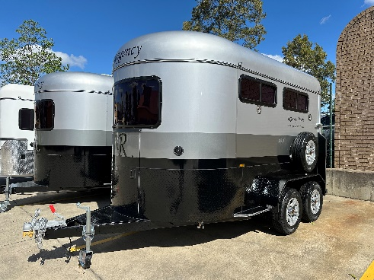

RF421

Round 2 HAL-SL

Colour: Silver top and roof, graphite bottom

Checker plate: Black

Vin. H1U6BMC21RM070056

Round 2 HAL Standard $22,995.00

Front cupboard with access door $ 849.00

Total $23,844.00

NEW YEAR SALE - $1,000.00

**Final total $22,844.00**

Deposit $ 1,000.00

Balance $21,844.00